St Vincent’s Chaplaincy
Praia da Luz
Newsletter
November 2018

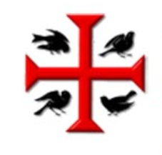

September 2018

Welcome
Welcome to the November edition of St Vincent’s Algarve West newsletter. Items for the newsletter can be sent to Fr Rob via email stvincentsalgarve.west@gmail.com
November is a time of Remembrance in more ways than one. We begin November of course by commemorating ALL SAINTS DAY on the 1st – remembering all those Christians who have gone before us, many of whom have been a great inspiration to us (not just ‘Saint XYZ’!). And it’s not necessarily so that those ‘recognised’ saints that we think about led ‘saintly’ lives either – most of the recognised saints were actually made saints after they themselves managed to rise above their own ‘issues’ shall we say.
Then we have All Souls’ Day on the 2nd November. This can be a controversial one in the Anglican Church as traditionally it is associated in the Catholic Church with praying for those souls in purgatory – think of purgatory as a half-way-house between Earth and Heaven! It is believed by some in the Catholic Tradition that there are souls ‘trapped’ in Purgatory, and if you pray for their souls they will eventually make it to heaven. I am saying nothing, due to ecumenical relations!! However, some Anglican churches also mark this day (there was a big service at St Paul’s Cathedral for example), and use it as a day to remember the lives of those we loved who have died, and to give thanks for their lives and that we shared it with them – so a slightly different take on All Souls’ Day between the Anglicans and the Catholics.
And of course we have Remembrance Day, where we give thanks and remember the great sacrifices made by those who served in the two ‘Great’ World Wars, and all those who have fallen in the service of their country at any time, more of that later.

This November, at our 11.30am Service on the 18th, we will also be remembering the Persecuted Church and Christians throughout the World. It’s both incredible that 2018 marks the 50th year of the formation of this organisation dedicated to keeping watch, intervening and praying for persecuted Christians around the World, and also extremely sad that they are still needed.
If anything though, they are perhaps needed more today than when they first begun 50 years ago. We will be adding our voices of prayer to theirs at our service, and to find out more about their incredible work, please feel free to get in touch with Jenny or Graham Aldridge via email - casaluz@hotmail.co.uk or visit the organisations website at https://releaseinternational.org
PERSECUTION UPDATE – NIGERIA
Christians in northern and central Nigeria are experiencing devastating attacks by militants.
Deborah’s husband was murdered by Boko Haram militants. Within a few weeks they also kidnapped her adopted daughters, killed her son and destroyed her home.
READ Deborah’s story in full in the recent issue of Release Magazine at Release International
PRAY for the work of Release’s partners in Nigeria who provide relief aid to displaced Christian families, and trauma-healing workshops to help Christians who have suffered violence.
PARTICIPATE in a service at Luz church on Sunday November 18th - the International Day of Prayer for the Persecuted Church - and generate a wave of prayer for our persecuted family.

Services for November/December
Just to ‘kick-off’ this newsletter, I thought I would let you know of the ‘Special’ or ‘One-Off’ services that I am sure you will all be asking about soon. November remains unchanged – there will be our usual 8am ‘Said’ Eucharist every Sunday, and our 11.30am ‘Sung’ Eucharist. In addition to our Sunday services, we also have a 10am Eucharist Service every Thursday.
During December
During December we will follow the same pattern as mentioned above, but there will be two special services – A Community Carol Service on the Wednesday 12th December at 6pm (this is the one that the schools come along to and we are treated to a snapshot of their Christmas school performances), and then there will be the joint Carol Service (which normally follows the format of Nine Lessons and Carols, but no promises!), on Wednesday the 19th December at 6pm.
There will also be a Christmas Day Eucharist Service at 11am (Tuesday 25th December!).
All the other services remain unchanged, apart from the fact there will NOT be a service on Thursday 27th December.
I hope to see you at some of them if you are going to be here.
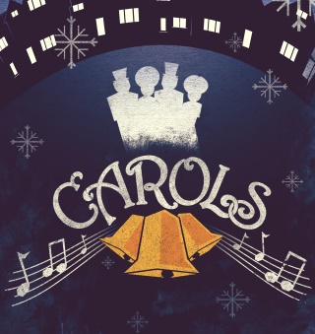
Coffee Morning
As many of you already know, the Coffee Morning went ahead on Saturday the 10th – that’s my excuse for getting this newsletter out a little late, as I desperately wanted to include some photos of the event.
So many people came together to help that (I am sure they won’t mind me saying), it wasn’t too taxing a day for the most part, and we all enjoyed it! The cakes, savouries, jams and chutneys that were donated to us from a willing army of volunteers was incredible, and we managed to raise a staggering €1449 Euros. So a huge well done and ‘pat-on-the-back’ to anyone and everyone who helped – it really was remarkable.
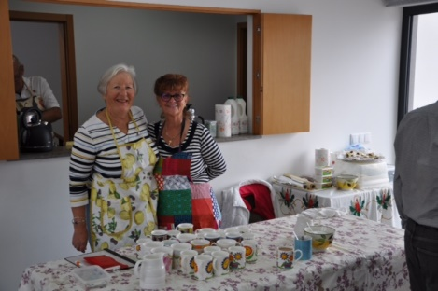
Cathryn & Lynette dishing up
tea or coffee and a slice of cake
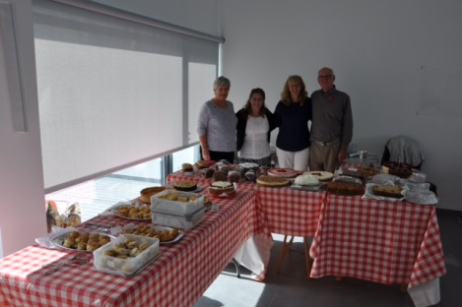
Marion Angela Sue and
Norman, on the cakes and
savoury stall
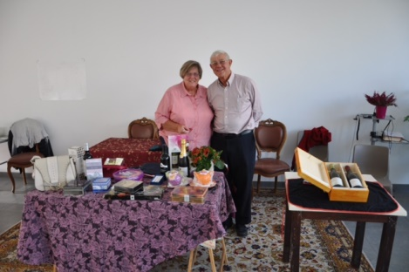
Joyce and John working the raffle

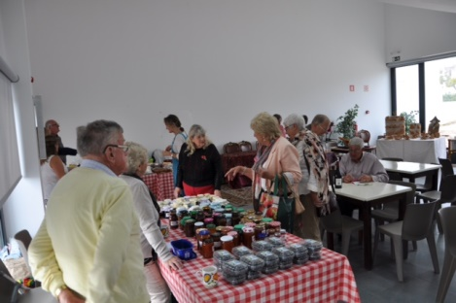
And lots of people having a
good time
For even more photos of the day, follow this link - http://bit.ly/LuzCoffee

Remembrance Day Poem
A few of you have asked me about the Remembrance Day poem that I read out at the Service of Remembrance here, and so I thought it would be nice to re-print it in the newsletter.
The poem was written by Darcey B, a Year 6 pupil at Oakhyrst Grange School in Surrey and it won East Surrey’s WW1 Centenary Poem Competition
With kind permission from her Grandmother, (a friend of Cathryn and Malcolm Peters), I am able to print it here. Well done Darcey.
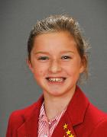
Darcey
One hundred years since the guns fell silent, Oh, how we remember the war, so violent.
The repetitive sounds of the guns in their ears, All across their faces, bloody smears.
Dead bodies all over the floor,
Begging, praying, ‘Please no more’
Muddy trenches where they slept
That was the place where they secretly wept.
Sharp as a thorn, the barbed wire lay
The war ground on, day after day.
A fatigued, listless faded air,
Everyone in need of desperate care.
We will never forget them, they were so brave, Each soldier that died, each life that was saved.
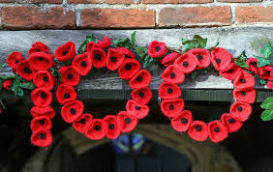
The poppy is worn with pride each November. Lest we never forget, we will always remember.

And Finally…
Just to say that as Advent & Christmas fast approach, we all need to keep an eye out that it doesn’t become Go-Go-Go as opposed to Ho-Ho-Ho! Advent starts on Sunday 2nd December, and we will be holding an Advent Bible Study beginning on Thursday the 29th November, after the morning service at 11.30am in the chapel at Casa do Jardim.
These normally prove quite popular, and so I would ask that you would email me to let me know you would like to come along, as, if it grows too big we may have to re-think a venue.
The study consists of 4 sessions, and is called Living Upside Down: the 40 days of Old Advent and it will take us right up to the week before Christmas, and it is possible to follow it online – no book is needed.
To download the sessions, click on this link
Course
You will need a PDF Reader to read the document that downloads.

Blessings and Peace
Fr Rob

