News from St Vincent’s Church, Praia da Luz (Church of England)
March 2018
Welcome to the Newsletter from Luz Anglican Church
Service Information for March
All Sundays. 8 am Said communion and 11:30 Sung communion.
Thursdays 10:00 Communion
Holy Week Services
Sunday 25th Palm Sunday 11:30 with a Passion Reading and distribution of Palm crosses
Thursday 29th Maundy Thursday 10:00 with Foot Washing
Friday 30th Good Friday 10:30 with reflective readings and music
Message from Fr. Rob
Primavera
Spring is in the air! Although actually, as I write this, it is absolutely chucking it down with rain! We keep reminding ourselves that the rain is much needed, and in a country that receives 320 days of sunshine a year, who can begrudge a little rain?
If I had to name a season that I favoured more than any other, I guess it would be Spring. Perhaps you are like me, and spring is your favourite too. There is something wonderful about coming out of the darkness of winter, often with its lack of colour, shorter days etc., something that is refreshing and hopeful when spring starts – blossom on the trees, a little warmer (hopefully), and the afternoon/evenings getting slightly longer. When the February half term comes, so too do we start seeing the first dribs and drabs of visitors coming back to the Algarve. In short, spring seems to give us a hopeful sign of things to come.
I think that’s also true of Lent and Easter. We purposely make Lent a ‘winter’ of sorts, with no flowers in the church, no singing of the Gloria (which is obviously deemed far too cheery for Lent!), we fast or abstain from something that we enjoy, and we build on that penitential ‘mood’ with a Maundy Thursday service, where we remember the last supper, followed by ‘Good’ Friday, the trial and crucifixion of Jesus.
But we do this in order to prepare for ‘our’ spring – Easter Sunday. When Easter Sunday comes, there is joy and celebration in churches around the world. Easter Sunday, the resurrection is like an eternal spring, it’s the human race coming out of its worst winter; into its best ever spring. It not only symbolises that we should have hope in the future, through the promises of eternal life, but that we should live even our worst moments of life, our personal winters or Lents, with the hope and expectation that they will surely be followed by our ‘springs’, our joyful Easter Sundays and the hope that this gives us for the future.
Spring is truly in the air!
May God bless you all this Easter.
Fr Rob

Lent Course
We are now 2 weeks into our lent course which is based on the book/film of Les Miserable. For each day of Lent there is a reading and when we get together on Tuesdays at 11:00 in the Saloa we discuss the meaning of the story which links to the bible readings. There are 2 main differences to previous lent courses, one is a number of people are following the daily readings who are not in Luz including one in Canada. The other important difference is the group is ecumenical with our English speaking catholic friends joining us and Padre Ze assisting Fr. Rob when he is available. Anyone interested can still join if they contact Fr. Rob.
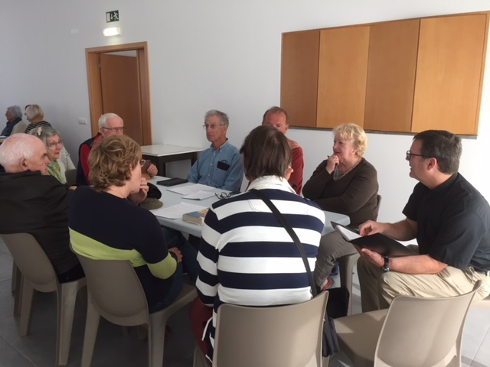
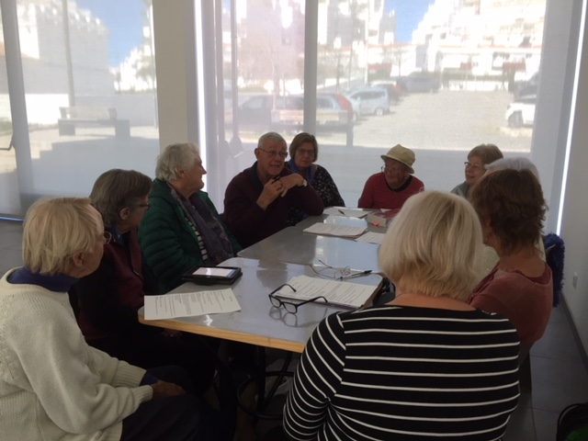
Quiz
The Annual Quiz evening took place at the Espiche Campsite on Friday 23rd February. After a buffet meal in the campsite’s restaurant the quizzing began. The Quiz Master Chris Farthing, hosted the quiz in his usual light-hearted manner, encouraging right answers with lots of clues and humour! This year we also had a local Guest Quiz Master John Daffey who had compiled a round entitled “Luz”. The quiz round themes ranged from Entertainment to Sport; from Food and Drink to History and Geography. There was something for everyone.
Spot prizes were awarded for the best team name – “Dimpled Balls” (I wonder what sport they played?) and for the best description of how teams had prepared for the quiz. Preparation techniques included “Went out for a 5-course meal to discuss strategy” and “No alcohol for 24 hours; believe that if you wish!”.
It was a close contest, the final totals were “Numskuls” – 77 points; “Dimpled Balls” and “The 12 Team” in joint 2nd place with 76 points and “The 4 Notes” in 4th on 73.5 points. “The Numskuls” claimed to have prepared for the Quiz by “recruiting a Professor and Crossword Expert from the U.S.A. and having him driven here by a Police Pursuit Driver”. Perhaps this explains their success even though they spelled Numbskulls wrong, which they said was deliberate (?)! The arduous task of scoring was carried out by Vicky Farthing
Such an evening can only function with the help of lots of people who worked hard before hand and at the event with a special thank you to Chris and Vicky who organised and hosted the event. Many of our usual helpers and quizzers couldn’t make it, but it was good to see so many newcomers swelling the ranks. The profits of the event, including a raffle, with lots of generously donated prizes will go towards church funds and to support local charities.
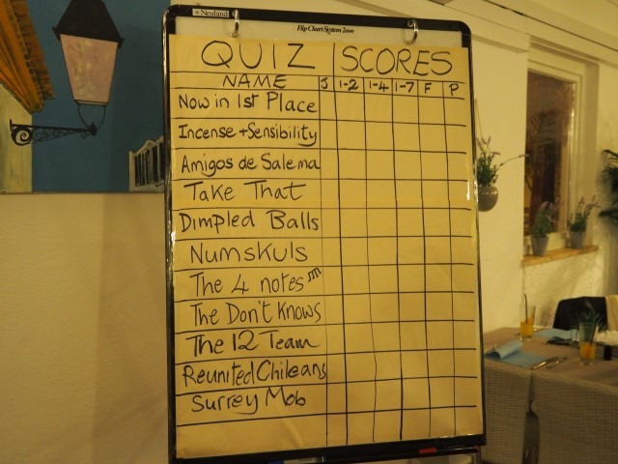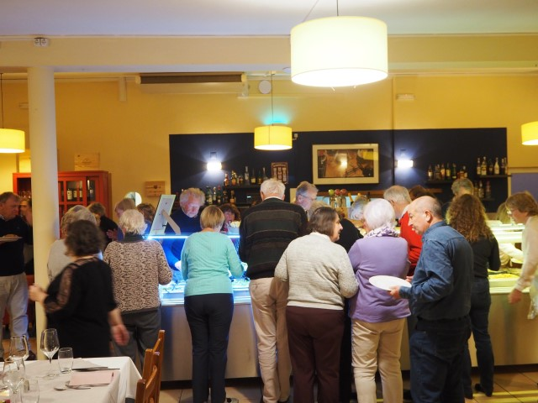
Mothers Day
We will be celebrating Mothers Day March 11th as always with posies of flowers for all the ladies and a lunch at Boavista golf club.
Chaplaincy Web Site
This has up to date information and reports about things happening in our chaplaincy. The Luz entries are being updated by Tricia Bechgaard, if you have anything about our church contact Tricia.
http://www.stvincentsalgarve.org
The Hundred Club started again last month.
Could we encourage you to participate.? The monthly draw has prizes of 3 x €100 . The cost is €10 per month i.e. €120 per year This raises for the Chaplaincy up to €8400 in a year. Please contact John Payne johndavidpayne@yahoo.co.uk Tel. 282 789 946 for more information ,and to join.
For any further information about services or fund raising please contact Joyce. Congregational warden
Tel.: 282 788 104 or 918824584 email joyce_daffey@hotmail.com

